
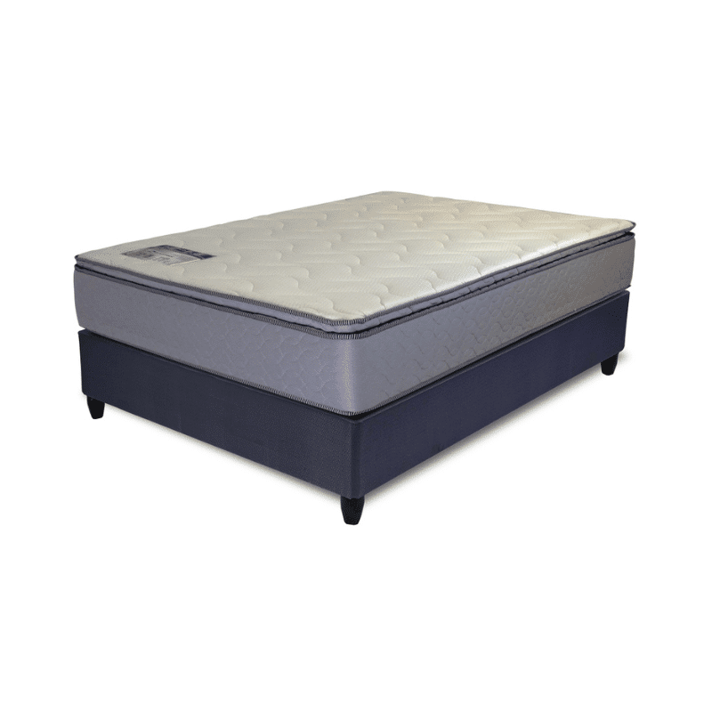

Model : Supapaedic Base Set
Supplier/Manufacturer : Rest Assured
Range : Matrix
Prices – Bed Set :
- Single Bed Set – R4749
- Three Quarter Bed Set – R5389
- Double Bed Set – R6339
- Queen Bed Set – R6929
- King Bed Set – R8719
Prices – Mattress Only :
- Single Mattress Only – R3489
- Three Quarter Mattress Only – R3969
- Double Mattress Only – R4799
- Queen Mattress Only – R4869
- King Mattress Only – R6199
Prices - Extra Length Bed Set :
- Single Extra Length Bed Set – R5129
- Three Quarter Extra Length Bed Set – R5829
- Double Extra Length Bed Set – R6849
- Queen Extra Length Bed Set – R7489
- King Extra Length Bed Set – R9419
Prices - Extra Length Mattress Only :
- Single Extra Length Mattress Only – R3769
- Three Quarter Extra Length Mattress Only – R4289
- Double Extra Length Mattress Only – R5189
- Queen Extra Length Mattress Only – R5259
- King Extra Length Mattress Only – R6699

*Please use this link for guideline for creating the page* - https://www.bedsonline.co.za/product/rest-assured-supapaedic-queen/
Rest Assured Link - https://restassured.co.za/our-ranges/matrix/supapaedic/

